**Bandit Level 4**

**“**The password for the next level is stored in a hidden file in the **inhere** directory.”

I went to the terminal and entered ls:



**Then:**



**Then when I saw the instructions say hidden – I entered command ls -la**

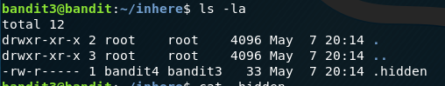

Then entered the command



Success! Copying password for level 4:

pIwrPrtPN36QITSp3EQaw936yaFoFgAB

Logging into SSG level 4:

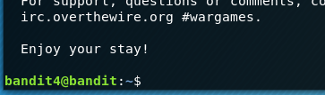

Success!